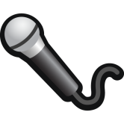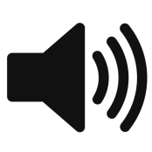

These will set configuration for the processor

Bridge Rectifier?  
What’s the needed current?

Volume Pot

Audio Amplifier & Filter

Microphone Amplifier & Filter

And / Or Both

User LED

8

User Buttons

Dip Switch

1.8 V  
Reg

H3 .1”

3.3 V

Tx

Rx

IO

External Connector  
RJ45?  
Ethernet?  
Wireless?

JTAG?

Programming Connector

Test Points

120 VAC  
Voltage

AC/DC Converter

IO

IO

IO

Processor  
STM 32 or ARM 8

DAC

IO

ADC

Are we using a premade audio codec chip?

Additional Things:

LED power indicators  
Reset switches

Things to Decide:

* Button debounce method, software, hardware?
* Volume pot analog or digital implementation
* What resolution does our ADC and DAC need to be?
* Frequency range of audio
* Are we breadboarding first?
  + What are the costs for the evaluation boards vs. ordering our own?
* I’d line toggle buttons with LEDs for rooms transmit indicators.
* What size is our serial packet? # of bits
  + Need one bit to say that someone is talking if half duplex
  + Need other bit for which rooms we are talking to / Receiving.